Macchanger lab:

# Host only:

1. Changing mac-address over a host-only mode. 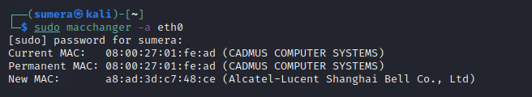
2. Changing back to the original mac-address. 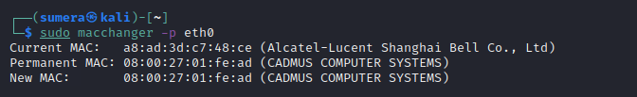
3. Customized mac address. 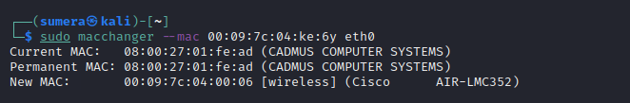
4. Randomized mac-address. 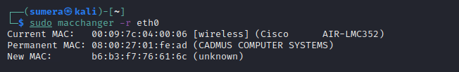

# Nat:

1. Host-only and Nat mode is not showing any apparent difference.

Randomly selected mac-address.

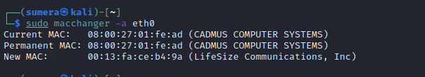

1. Trying burn-in-address option. 